**PS APP Deploy Toolkit Commands**

1. **Show-ADTInstallationPrompt**

**Displays a progress dialog in a separate thread with an updateable custom message.**

**DESCRIPTION**[**​**](https://psappdeploytoolkit.com/docs/reference/functions/Show-ADTInstallationPrompt#description)

**Displays a custom installation prompt with the toolkit branding and optional buttons. Any combination of Left, Middle, or Right buttons can be displayed. The return value of the button clicked by the user is the button text specified. The prompt can also display a system icon and be configured to persist, minimize other windows, or timeout after a specified period.**

Show-ADTInstallationPrompt -Message 'Do you want to proceed with the installation?' -ButtonRightText 'Yes' -ButtonLeftText 'No'

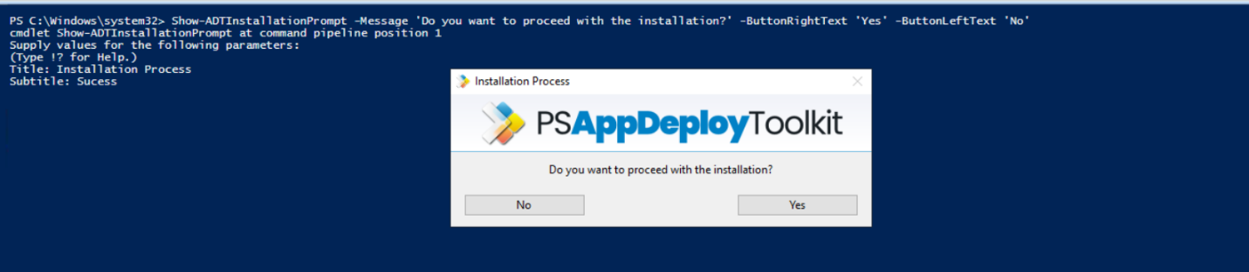

1. **Show-ADTInstallationWelcome.**

**Show a welcome dialog prompting the user with information about the deployment and actions to be performed before the deployment can begin.**

**DESCRIPTION**[**​**](https://psappdeploytoolkit.com/docs/reference/functions/Show-ADTInstallationWelcome#description)

**The following prompts can be included in the welcome dialog:**

* **Close the specified running applications, or optionally close the applications without showing a prompt (using the -Silent switch).**
* **Defer the deployment a certain number of times, for a certain number of days or until a deadline is reached.**
* **Countdown until applications are automatically closed.**
* **Prevent users from launching the specified applications while the deployment is in progress.**

Show-ADTInstallationWelcome -CloseProcesses @{ Name = ‘winword’ }, @{ Name = ‘excel’ } -Silent

1. **Show-ADTDialogBox.**

**Display a custom dialog box with optional title, buttons, icon, and timeout.**

**DESCRIPTION**[**​**](https://psappdeploytoolkit.com/docs/reference/functions/Show-ADTDialogBox#description)

**Display a custom dialog box with optional title, buttons, icon, and timeout. The default button is "OK", the default Icon is "None", and the default Timeout is None.**

**Show-ADTInstallationPrompt is recommended over this function as it provides more customization and uses consistent branding with the other UI components.**

Show-ADTDialogBox -Title 'Installation Notice' -Text 'Installation will take approximately 30 minutes. Do you wish to proceed?' -Buttons 'OKCancel' -DefaultButton 'Second' -Icon 'Exclamation' -Timeout 600

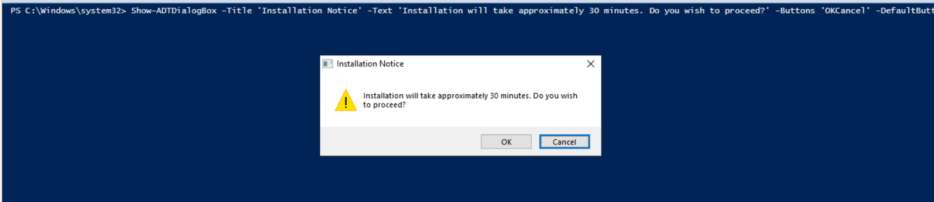

1. **Show-ADTBalloonTip**

**Displays a balloon tip notification in the system tray.**

**DESCRIPTION**[**​**](https://psappdeploytoolkit.com/docs/reference/functions/Show-ADTBalloonTip#description)

**Displays a balloon tip notification in the system tray. This function can be used to show notifications to the user with customizable text, title, icon, and display duration.**

**For Windows 10 and above, balloon tips automatically get translated by the system into toast notifications.**

Show-ADTBalloonTip -BalloonTipText 'Installation Started' -BalloonTipTitle 'Application Name'

1. **Show-ADTInstallationProgress**

**Displays a progress dialog in a separate thread with an updateable custom message.**

**DESCRIPTION**[**​**](https://psappdeploytoolkit.com/docs/reference/functions/Show-ADTInstallationProgress#description)

**Creates a WPF window in a separate thread to display a marquee style progress ellipse with a custom message that can be updated. The status message supports line breaks.**

**The first time this function is called in a script, it will display a balloon tip notification to indicate that the installation has started (provided balloon tips are enabled in the config.psd1 file).**

Show-ADTInstallationProgress -StatusMessage 'Installation in Progress...' -WindowLocation 'BottomRight' -NotTopMost

**Practical** **Commands**

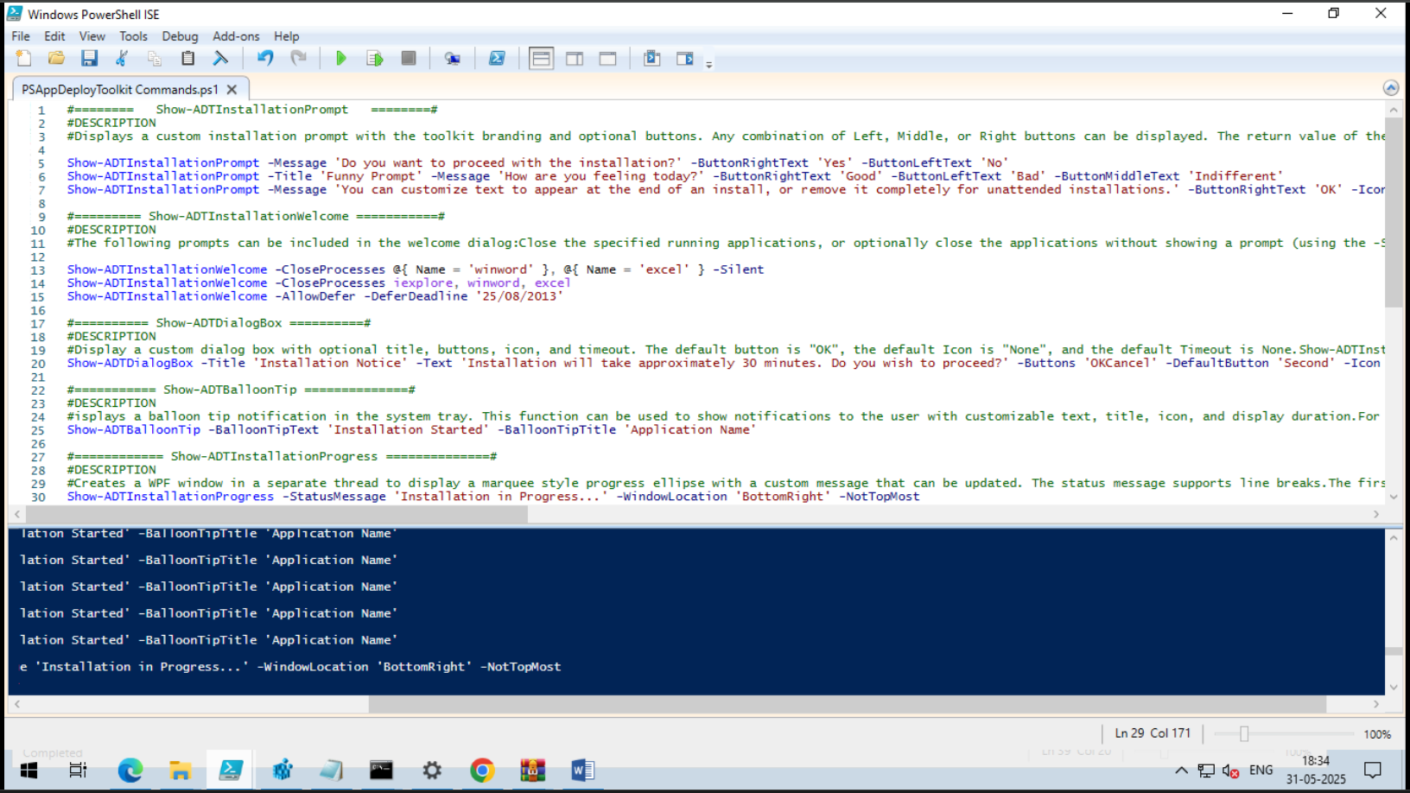

* **Known issues and troubleshooting tips for the MSIX Packaging Tool**

1. **Known issues**

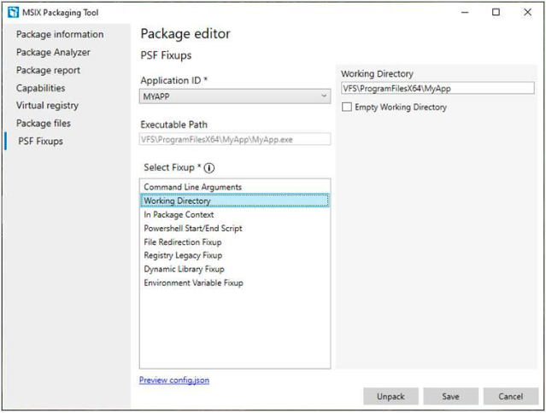

* + **Getting the latest Insider Preview build of the MSIX Packaging Tool**
  + **MSIX Packaging Tool driver**
    1. **Network connectivity issues**

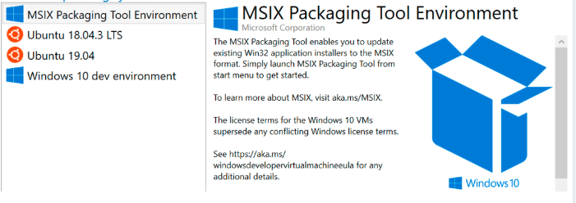

* + **Windows Server Update Service (WSUS), Configuration Manager, or group policies affecting Windows Update connectivity**
    1. **Driver required a reinstall**
    2. **Error starting the MSIX packaging tool driver 0x80131500**

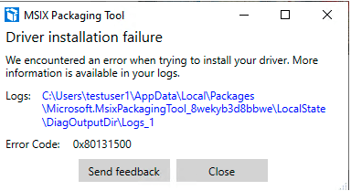

* + **Minimum version**
  + **Enforce Microsoft store versioning requirements**
  + **MSIX with services**
  + **Frameworks and drivers**
  + **Remote Machine**
  + **Issues during conversion**
  + **Issues during signing**
  + **Bad PE certificate (0x800700C1)**
  + **Device Guard signing**
  + **Expired certificate**

1. **Troubleshooting**



* **Log files: Whether or not your conversion was successful, log files are generated for every conversion. They can be found here:**

%localappdata%\packages\Microsoft.MsixPackagingTool_8wekyb3d8bbwe\LocalState\DiagOutputDir\

* + **Log files from remote devices or VMs**

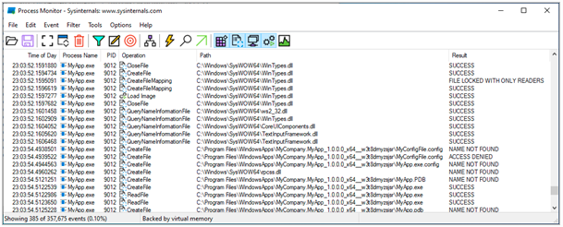

* **Common problems**
  + **MakePri/Manifest translation errors**
  + **File not found**
  + **File Type Associations**
* **Shortcuts with arguments**
* **Install directory**